

**USER MANUAL WORLD CUP ON THE GO**

SCSJ3253: TEKNIK PENGATURCARAAN III

- PM Dr Mohd Shahizan Othman –

Team Member:

1. Nur Ainon Binti Yusmadi – SX172096CSJF04
2. Sobery Bin Basri – SX180091CSJS04
3. Savith Kumar Raj Gulab – SX180279CSJS04
4. Mohammad Hafizzuddin Bin Mohd Zin – SX180405CSJS04

**Getting started with World Cup on The Go**

**Public User** #F5F5DC

**STEP 1 1** #F5F5DC

**The main page will be displayed as shown Figure 1 below**

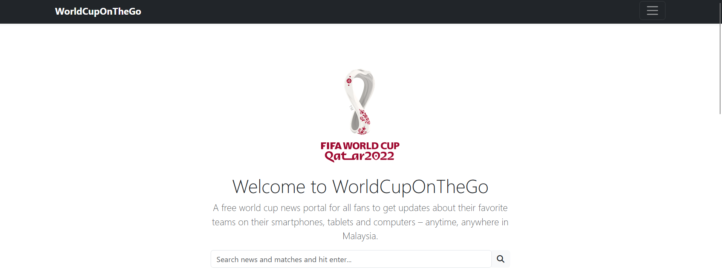

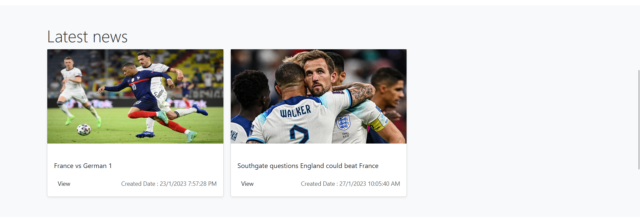

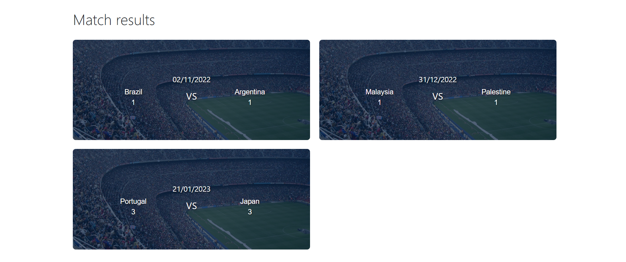



Figure 1

**Search using the keywords ‘Argentina’ or anything you want to search and the result will display**

**STEP 2 1** #F5F5DC



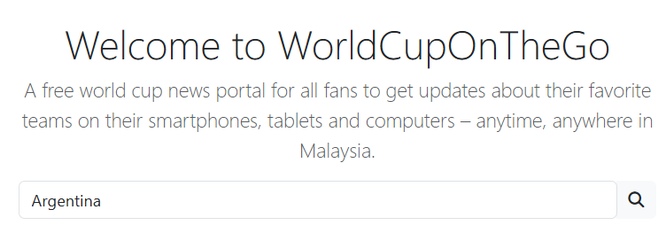

Press **Enter** for retrieve the result

**The result of searching will be displayed as shown Figure 2 below**

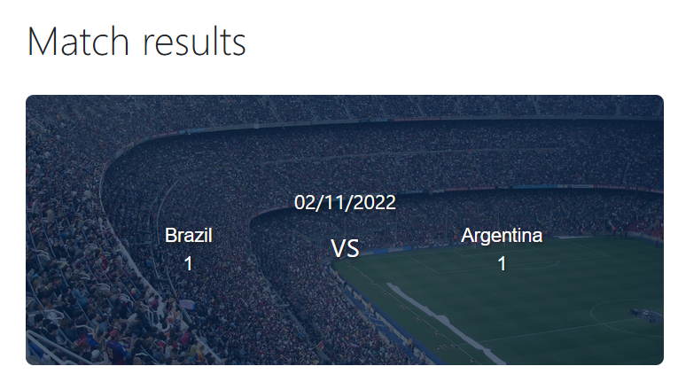

Figure 2